<https://www.youtube.com/watch?v=FgakZw6K1QQ>

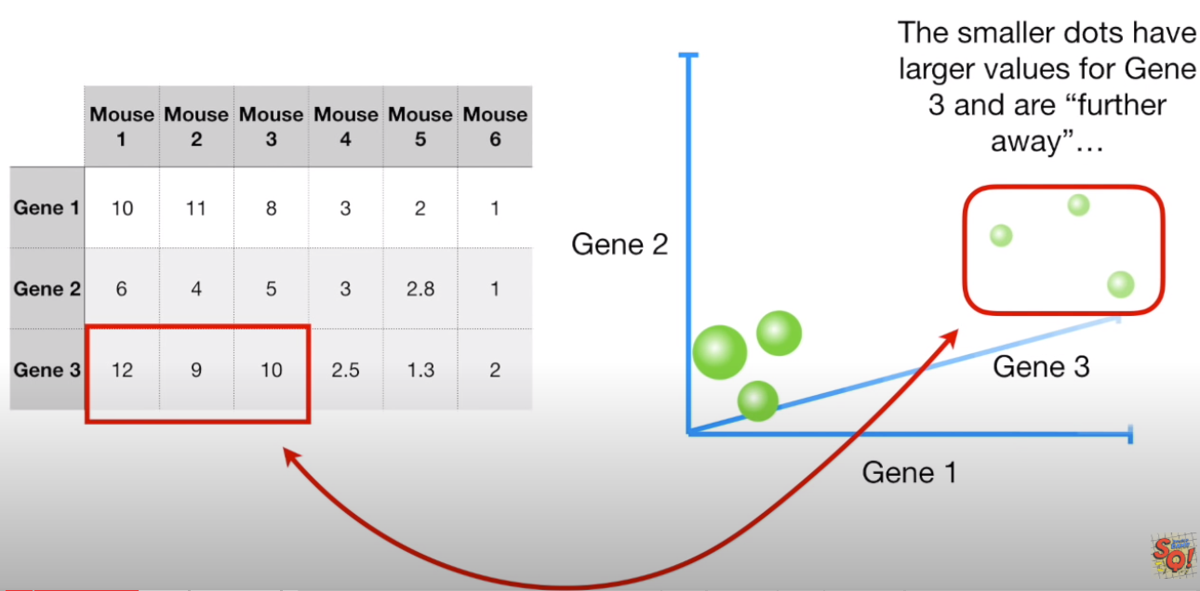

4 genes require 4 dimensions ☹.

Using PCA, we will learn how to take 4-dimensional data and convert it to 2-dimentional PCA plot.

This plot will show us that similar mice cluster together:

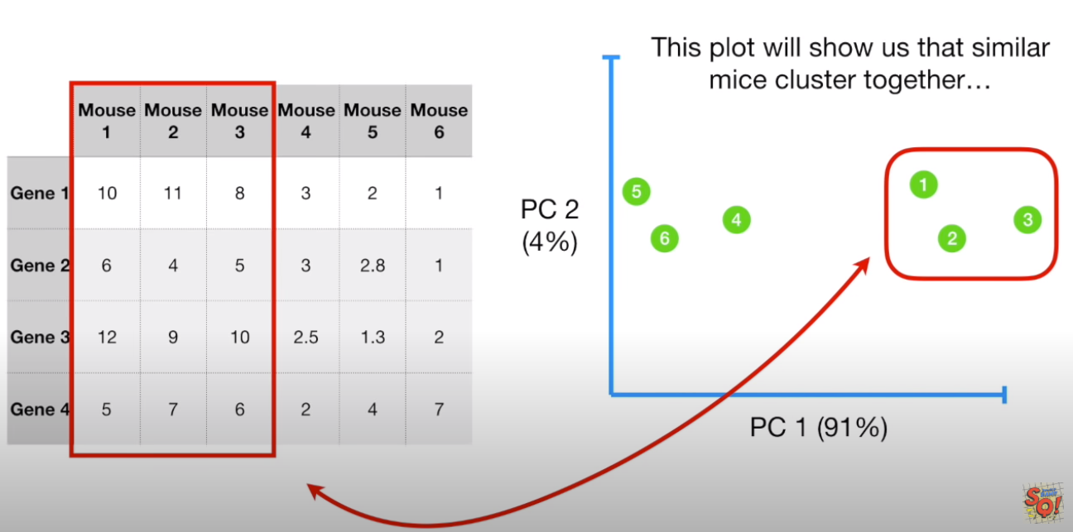

In addition, PCA can tell us which gene is responsible for separating the data.

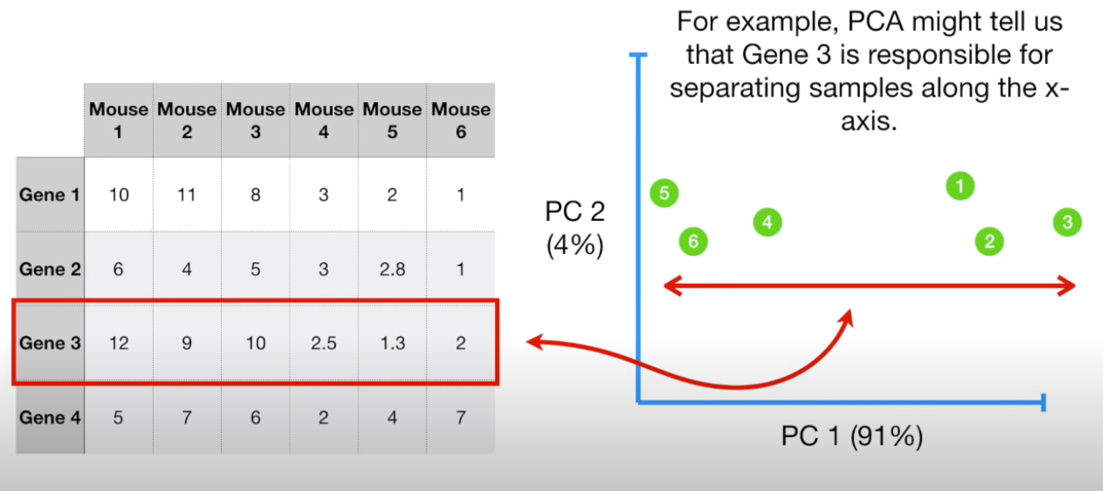

To start how PCA works, lets go back to the two Genes situation:

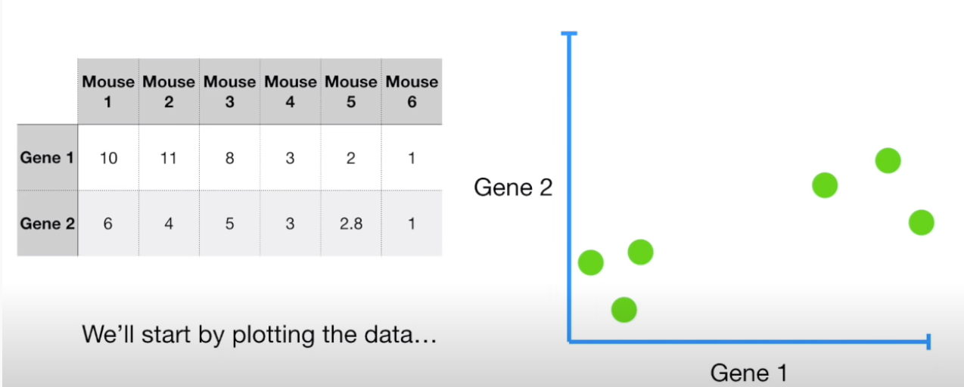

We calculate the average measurement for gene one and gene two:

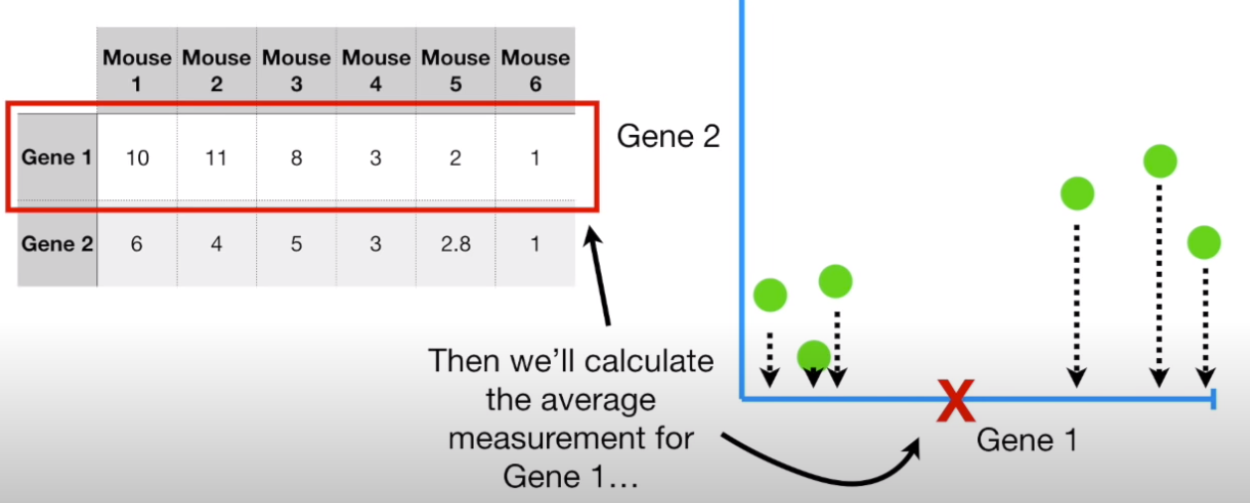

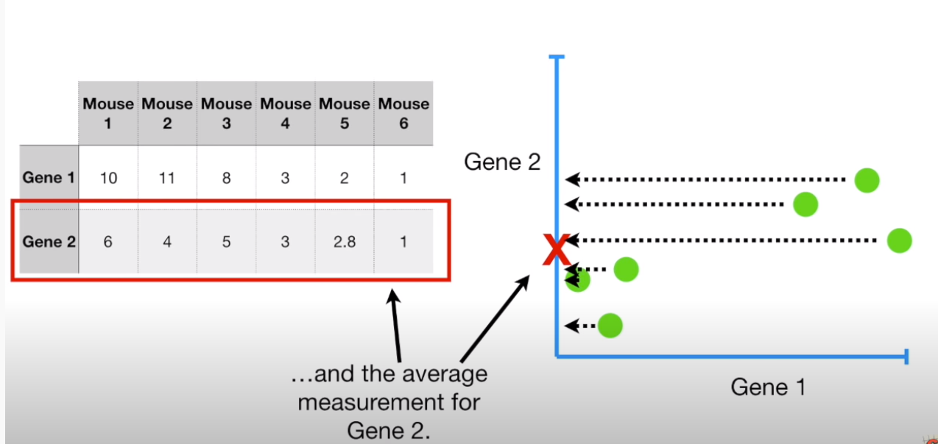

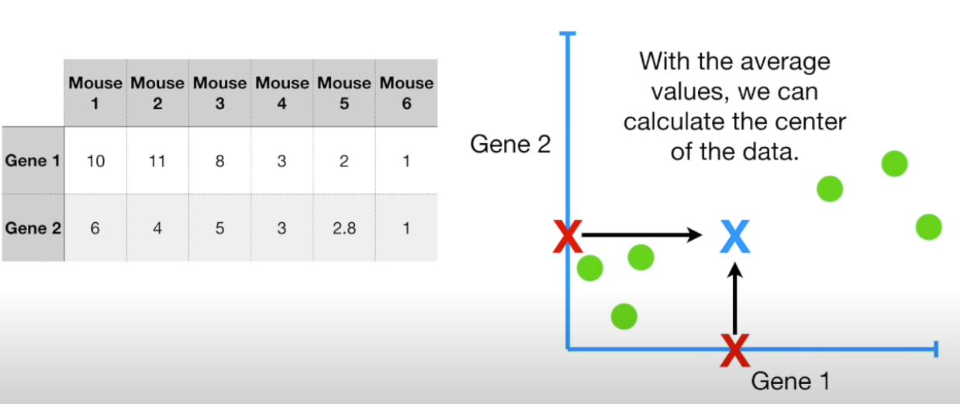

We move that data to the center.

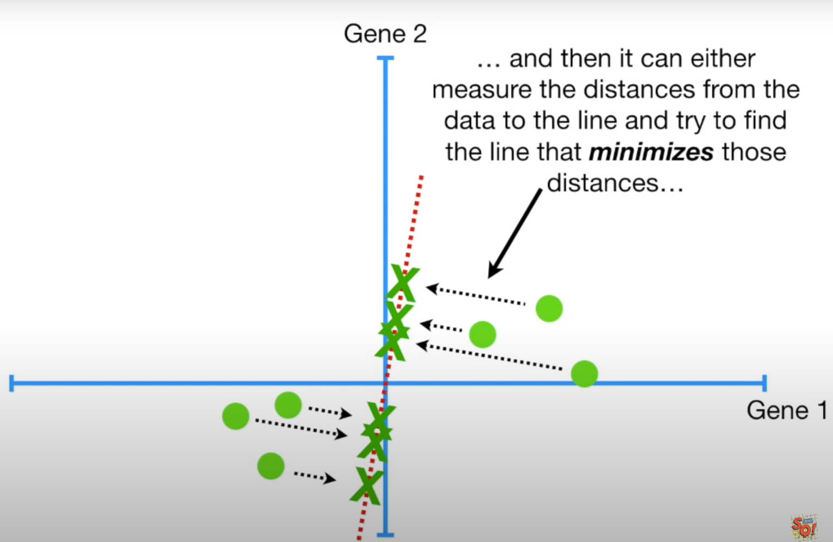

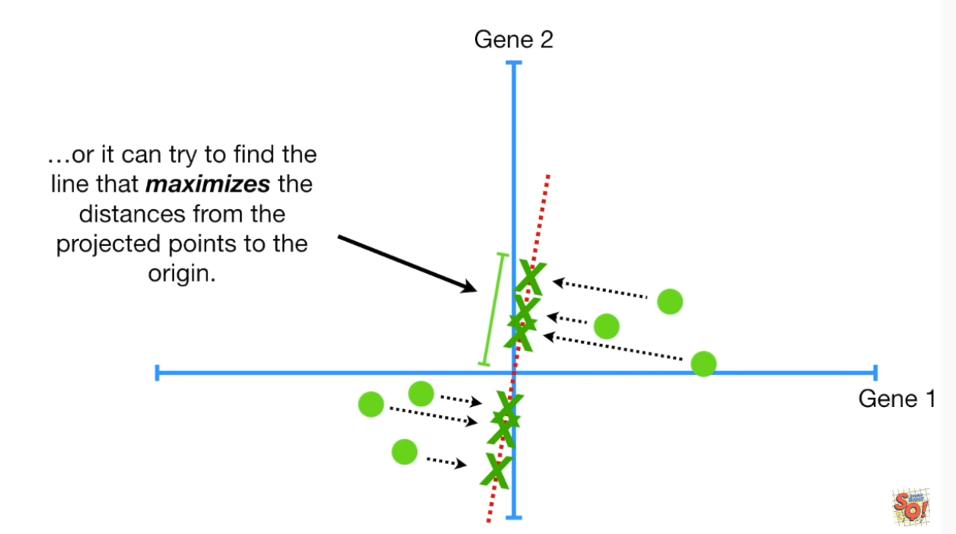

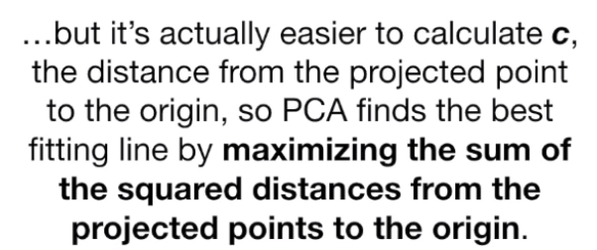

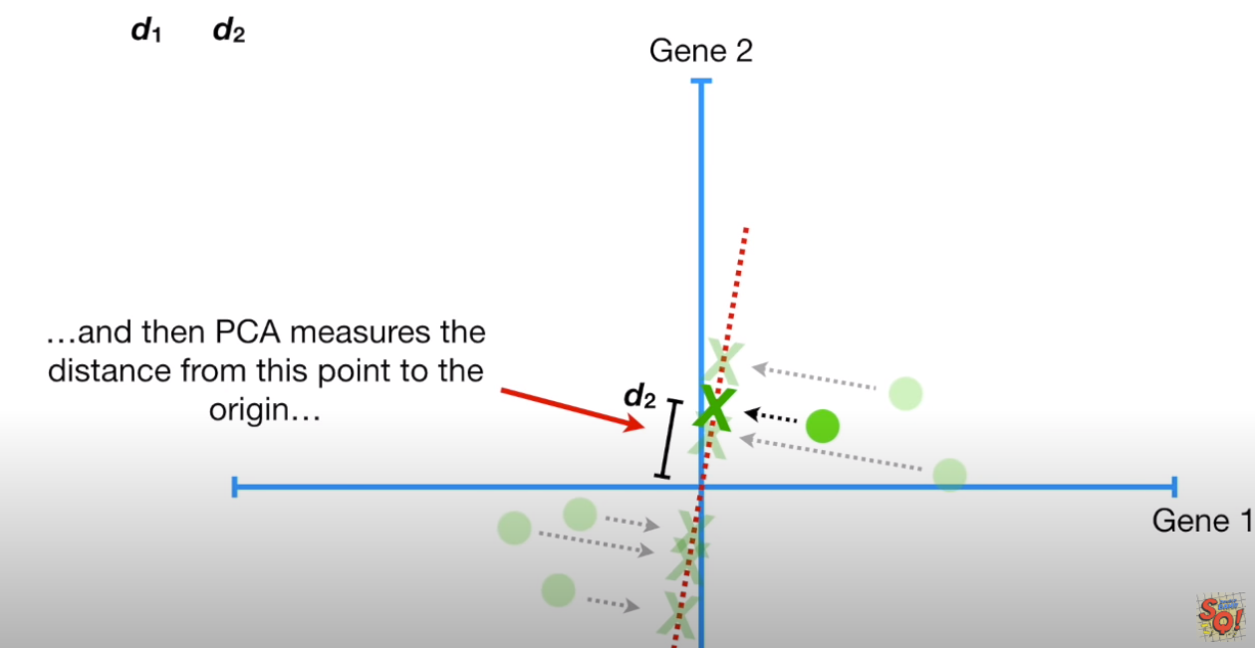

**Continue Later…**